# CS 255 System Design Document

Andrew Bartle

## UML Diagram

### UML Use Case Diagram

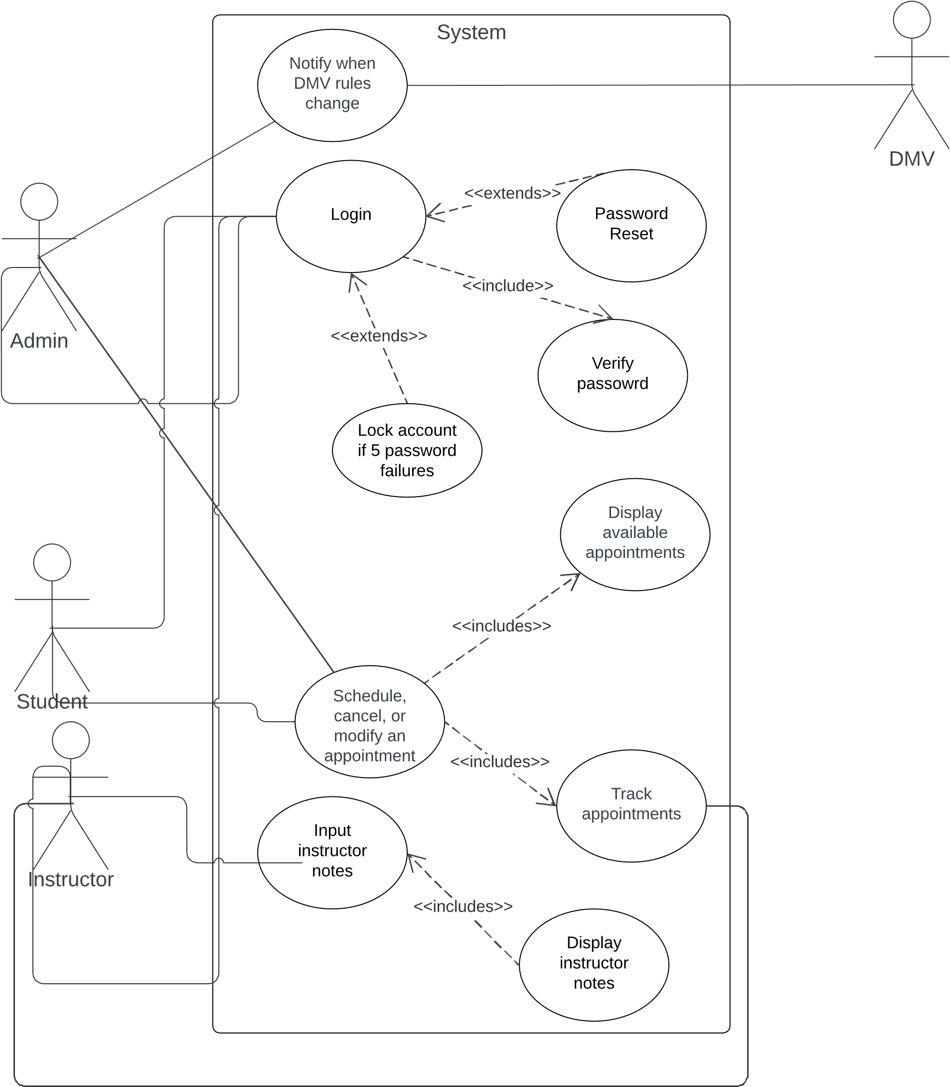

### UML Activity Diagrams

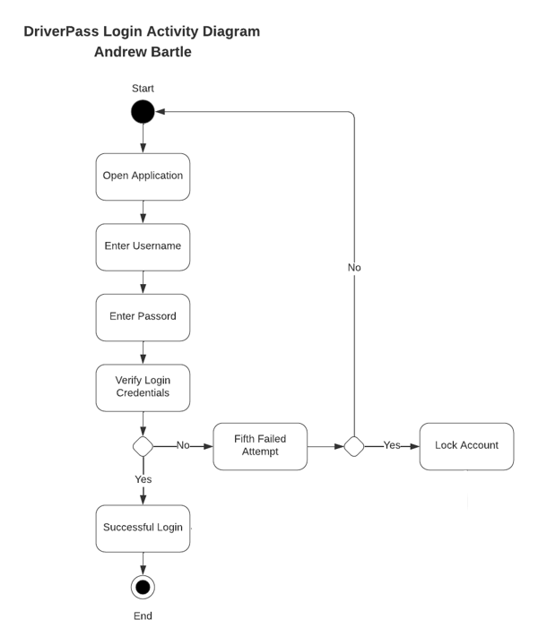

### UML Sequence Diagram

### UML Class Diagram

## Technical Requirements

**Client Hardware Requirements**

1. Power source
2. Desktop or laptop (with ethernet card)
3. Internet Service Provider (ISP)
4. Cat5 cable for internet connection

**Host Hardware Requirements**

1. Amazon cloud services will be used. Hardware requirements will be in Amazon’s scope.
2. A physical server (with ethernet card)
3. Power source
4. Internet Service Provider (ISP)
5. Cat5 cable for internet connection

**Client Software Requirements**

1. Web browser (Edge, Chrome, Firefox, etc.)
2. Windows operation (Windows, Mac, Linux, etc.)

**Host Software Requirements**

1. Windows Server
2. MySQL database
3. Security software
4. Credit card transaction processing service

**Development Tools**

1. Internet connection
2. Integrated Development Environment (IDE) such as Visual Studio, MySQL Workbench, etc.

**Infrastructure requirements**

1. Credit card transaction processes service
2. Power source
3. Internet Service Provider (ISP) with high-speed internet
4. Physical server storage